ARRL Field Day 2023
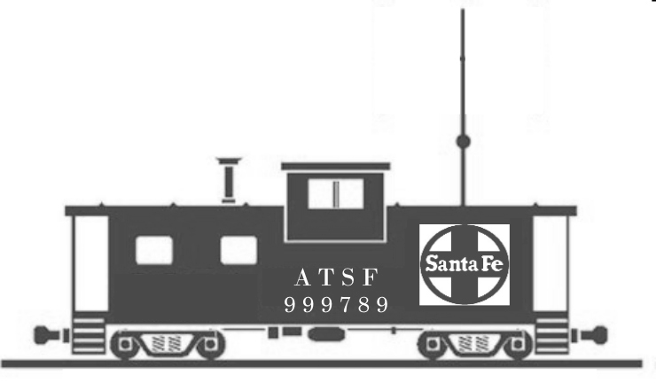

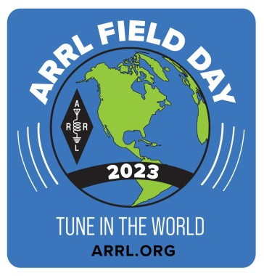

Amateur Radio Event
- Visitors Welcome - STARS Amateur Radio Club
June 24 and 25, 2023
24 hours - 1:00PM Sat. thru 1:00PM Sun. Amateur Radio License Testing 11:00AM
Santa Fe Prairie State Nature Preserve 7300 River Rd, Hodgkins, IL
Parks On The Air K-7839
Field Day is an emergency-preparedness exercise for Amateur Radio Operators Multiple Stations are set up in the Field with portable antennas and powered by Batteries, Generators, Solar, or other non-commercial sources. Operators contact Stations all over the U.S. And Canada using Microphone, Morse Code, and
and Digital Communications
The purpose of Field Day is to introduce the General Public to Amateur Radio, to demonstrate Sending and Receiving short messages for a simulated emergency, when storms or other disasters cause power, cell phone, and internet outages
This is an All-Weather Event. The Santa Fe Caboose Vistor Center is open 10:00 am to 2:00 pm on Saturdays and Sundays
Santa Fe Prairie State Nature Preserve is located near I-55 and 67th Street in Hodgkins, IL

STARS W9SRC
w9src.org

